**CHAPTER ONE**

**1.0 INTRODUCTION**

One of the most commonly used languages in the Western world is the English language which is the Nigerian lingua franca which is commonly spoken among tribes in the country. which has therefore posed a threat to the survival of indigenous Nigerian languages. Most children cannot speak their mother tongue. Therefore, experts are agitated that if a child cannot speak his or her mother tongue today, there is the probability that in the next 25 to 30 years the sons and daughters of the land may lose the language. This implies that in the next 50 years or more, the fate of Nigerian languages such as Yoruba, would be close to near extinction. The recent policy of Nigeria Federal Ministry of Education that made the study of indigenous languages optional in Senior Secondary Schools does not help matters. Therefore this research provides a means of preventing the extinction of Yoruba language. Also, it helps in the flow of globalization by developing a web-based user-friendly English to Yoruba Machine Translation System. The system is easily accessible to learning and to teaching the indigenes and anyone interested in the Yoruba language. The electronic translator is user-friendly and English words are easily translated to Yoruba words. In addition, it assists in understanding the Yoruba language with the English language. (Anil, 2020).

The Yoruba language is a dialect (natively ede Yoruba) of West Africa with over 25 million speaker. The traditional area, “Yoruba Land”, Benin, Togo, etc. Yoruba is a Niger-Congo language spoken in West Africa. The number of Yoruba language speakers was estimated around 20 million in the 1990’s and Togo and among other communities in other parts of Africa, Europe, and America.

A dictionary (also called word stock, word reference, wordbook, lexicon, or vocabulary) is a collection of words in one or more specific languages, often listed alphabetically (or by radical and stroke for ideographic languages), with usage information, definitions, etymologies, phonetics, pronunciations, and other information or a book of words in one language with their equivalents in another, also known as a lexicon.

**1.1 BACKGROUND OF STUDY**

The Yoruba group is assumed to have developed out of in differentiated Volta-Niger populations by the 1st millennium BC. Settlements of early Yoruba speakers are assumed to correspond to those found in the wider Niger from about the 4th century BC, especially at Ife.

Standard Yoruba has its origin in the 1850s when Samuel Ajayi Crowther, the first Africa Bishop. Published a Yoruba grammar and started his translation of the bible.

The various Yoruba dialects in Yoruba land of Nigeria can be classified into the major dialects area; North-WPA Yoruba (NWYU) Abeokuta, Ibadan, Oyo, Ogun, and Lagos(Eko) areas.

**1.2 STATEMENT OF THE PROBLEM**

The existing system of Yoruba translators has the following drawbacks:

1. Error in translating Yoruba words.
2. Difficulty in identifying a good translator

**1.3 AIM AND OBJECTIVES**

**AIM**

The major aim of this project is to develop a system that can first improve the existing system and helps in the translation of the general English language into the Nigeria Yoruba language.

**OBJECTIVES**

The objectives of this study are:-

1. To allow users to know the correct meaning of a particular Yoruba word.
2. To train learners/user in the use of an electronic dictionary.
3. To help user/learner in knowing the proper spelling of words.
4. To help students develop a more natural command of Yoruba.
5. To make user knowledge to be increased along with his/her Yoruba dialect.
6. It could be a guide as to know particular word should be used.
7. To make user to develop autonomy and confidence in himself/herself.
8. To enable students to understand the meaning of words quickly and almost effortlessly.

# 1.4 SCOPE OF STUDY

**(NIGERIA LANGUAGE AND COMMUNICATION SOCIETY)**

This project work is to interpret Nigeria language (Yoruba) to its English equivalent language with a multilingual functionality as well

**1.5 LIMITATION OF THE STUDY**

Owing to the scope of this project work as stated above, this project work is to design and implement a language translator system that can translate the standard English language to the Nigeria general Yoruba language. It is important to mention here that time was a major constraint in the course of fact-finding other constraints Include:

1. The Machine translation translates each of the sentences literally, with no consideration being made in terms of the context of the text or the expressions unique to each language, creating unintelligible phrases constantly.
2. Inability to get tech resource persons who can work at the back end in the Admin Panel in respect to the projects
3. Poor network facility and Data constraints in uploading contents

**1.6 SIGNIFICANCE OF THE STUDY**

With the growth in information technology, the study offers numerous benefits to the Ogun State government, other Yoruba states, and to any organization to implement the electronic language translator that deals on translating multiple forms of text and media, which includes text, speech, and text within still or moving images. Specifically, its functions include: Written Words Translation: a function that translates written words or text to a foreign language.

**1.7 METHODOLOGY**

The Method of data collection was through observation and the making of little research but together. Hence, in putting forward method to the accomplishment of this project, programming languages like JAVASCRIPT for consuming the and HTML, CSS were used extensively and proper data modeling(ER Diagram) were used. Proper documentation had been made so far.

# 1.8 DEFINITION OF TERMS

**LANGAUGE**: the principal method of human communication, consisting of words used in a structured and conventional way and conveyed by speech, writing, or gesture[.](http://en.wikipedia.org/wiki/Money)

**COMPUTER**: A computer is a programmable [machine](http://en.wikipedia.org/wiki/Machine) that receives input, stores and manipulates [data,](http://en.wikipedia.org/wiki/Data_%28computing%29) and provides output in a useful format.

**TRANLATOR**: A designed or developed program for translating written instructions from its main source to other format.

**DATABASE**: A database is a system intended to organize, store, and retrieve large amounts of data easily. It consists of an organized collection of data for one or more uses, typically in digital form.

**SYSTEM**: whole compounded of several parts or members, system", literary "composition". Is a set of interacting or interdependent [system components](http://en.wikipedia.org/wiki/Components) forming an integrated whole.

**INFORMATION**: is a processed data.

**STORAGE**: is a device for recording (storing) information (data) **STAFF**: a set of people, such as the [employees](http://en.wikipedia.org/wiki/Employment)or [volunteers,](http://en.wikipedia.org/wiki/Volunteering) within an organization.

Bottom of Form

**CHAPTER TWO**

**LITERATURE REVIEW**

**2.1 THE CONCEPT OF TRANSLATION**

The term or world translation is generally defined as a process of changing the form of the original language (the general source language or SL) into different languages (the target language or TL). This process accords with an intra-lingual translation which is an interpretation of verbal signs through some other languages (Munday, 2016: 8). Another definition is proposed by Larson (1998:3) who states that translation is a process of transferring meaning from texts in the source language into the receptor language. The process must be done by changing the form of the ST to the form of the TT in the semantic structure through a well-organized means. The meaning is maintained, only the forms change. Catford (1978: 20) explains that translation is the change of textual material in one language (SL) by equivalent textual material in another language (TL). The term textual material underlines the fact that it is not the entirety of SL text which is translated but replaced by target language equivalents. For example, if we translate the Indonesian text “Berapaumurmu?” into English as “How old are you?”, there is replacement of source language (Indonesia) grammar and lexis by equivalent target language (English) grammar and lexis. Eberhard, Julky 2021

Based on Newmarkdefinition, there are two approaches in the translationprocess:

**i**. When you start translating in the first paragraph or chapter sentence by sentence, getthe feels and tones of the text, and then doing the crosscheck to review theproject, and the last, reading the rest of the SL text.

**ii**. Read the whole source text two or three times; find the intentions,registers, and tones; marking the difficult words and paragraphs; and starttranslating only when the translators have found a comfortable situation.

Regarding the above theoretical foundation, the researcher summarizesthat translation is a process of transferring the message of the source languageor natural language into the target language or receptor language. The processmust be done by changing the form of the ST to the form of the TT in thesemantic structure. There are two approaches to translations. Both approachesare available for certain conditions based on the translator's intentions.

**2.2 APPROACHES TO TRANSLATION**

1. Translation Process: The translation process is an order of technical devices to transfer the message of the source language to the equivalent target language. The translation process can be described as understanding the meaning of the source text and then express this meaning into the target language without ignoring grammar, syntax, idioms, and also the culture of the related target language text. Nida and Taber as cited in Budianto and Fardhani (2015: 30) defined the translation process in three steps as follows.

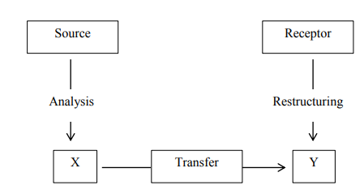

Fig 2.1 Steps of Translation Process

Source: https://eprints.uny.ac.id/66265/3/BAB%20II

1. Understanding the meaning or message of SL text, through analyzing its words, phrases, and sentence structures or grammar used in the sentences.
2. Finding out the equivalent meanings of the text to transfer the analyzed messages in the source language into the target language messages. This step is called an internal process;
3. Reconstructing the equivalent meanings of SL to TL with equivalent forms or sentence patterns. The messages in the TL must be the same as the message in SL. When some adjustments of lexical or grammatical are done, transformation happens. If the result is already fit between SL text and TL text, translation is written.
4. **The Methods of Translation:** Newmark mentions the difference between translation methods and translation procedures. He quotes that translation methods relate to the whole text, while translation procedures are used for sentence and the smaller unit of language. It means that translation methods have a bigger scope thantranslation procedures.
5. Word-for-word translation: The words of the target language are directly put below the source language words. The words in source languages are translated singly and cultural words are translated literally which is not restricted to the context. Word for word translation is used to either understanding the form of source language or elaborating difficult words as a pre-translation process. (Eberhard, 2021).
6. Literal translation Literal translation is the method above word for word translation. The lexical words are translated based on the dictionary, beyond contexts, but the grammatical structures of the source language are adapted to the closest target language equivalents.
7. Faithful translation A faithful translation attempts to maintain source text composition. It reproduces the appropriate contextual meaning of source language within the SL Emphasis TL Emphasis Word for Word Adaptation Literal Translation Free Translation Faithful Translation Idiomatic Translation Semantic Translation Communicative Translation 16 restriction of the target language grammatical construction. The cultural words are transferred, the degree of grammatical and lexical deviation from source language norms are preserved in the translation. The translation result is sometimes awkward because the sentence is translated faithfully text-realization of the source language.
8. Semantic translation Semantic translation is different from faithful translation. Faithful translation sounds more awkward to the target language rule, while semantics translation takes more account of aesthetic aspects compromising the meaning. The translation will sound more beautiful and natural. The word which has a little cultural content can be translated into the neutral or functional term. For instance, “She is a book-worm” is translated into “Dia (perempuan) adalahseorangkutubuku”. This translation has the functional characteristic, that is, can be easily understood, though there is no cultural equivalent in the target language. (Laurie 2015)
9. **Translation Procedures:** The variety of terminology due to translation procedures is debatable among scholars. Procedures, strategies, techniques, and processes are the most common terms used to refer to translation operation (Bardaji, 2009). Krings in Guerra (2012: 5) states that translation strategies are defined as the procedure that leads to examine a translation problem so its function is 18 regarded as the optimal solution. Molina and Albir (2002: 509) state that a technique tends to recognize the result of a choice made by the translator. Besides, they define the translation technique as procedures to analyze and classify how translation equivalence works. According to the definition of those terms, it can be concluded that each term has a similarity which refers to the solution of the translation process used by the translators. (Bodnar, 2014)
   1. **RESEARCH REVIEW OF EXISTING WORK**

Locally in Nigeria, not so much has been done in machine translation of local languages. However, it is worth reflecting on some previous efforts. Developed a machine translator for the English and Yoruba languages using classic syntactic and semantic analysing algorithms. Described a Statistical Machine Translation (SMT) system that translates English sentences to Yoruba sentences. The resulting software provides tools to tackle the problem of language translation between Yoruba and English language. The software employed a machine translation paradigm where translations are generated on the basis of statistical models whose parameters were derived from the analysis of bilingual text corpora. Gave an account of Yoruba text-to-speech (TTS) system development using the concatenation method.analysis of the results their work showed that, 70% respondents accepted its usability. In 2015, a few Natural Language Processing research projects aimed at producing automated language translators and providing unique and important insights into the Natural Language Processing (NLP) of African Languages commenced in Nigeria: These projects were focused on the development of automated machine translation software for Igbo - English as well as Yoruba-English, and the development of a functional corpus of computer-readable Yoruba texts in standard orthography and a Statistical Language Model (SLM) of Yoruba. These projects were sponsored by the African Languages Technology Initiative (ALT-I) – a research and development agency with a mission for taking African cultures into the Knowledge era (http://www.alt-i.org/?page_id=31).

Generally, there are many programs now available that are capable of providing useful output within strict constraints. Most of these programs are available online, such as Google Translate and the SYSTRAN system which powers Alta Vista Babe fish. (https://www.researchgate.net/publication/326722662)

The previous system makes use of the natural means of translation and if need to be documented they make us of the word processing package which is the MS WORD, POWER POINT for multimedia authoring. The concept of the multimedia authoring is to provide a nearly suitable means by which audio record can be played alongside with the written text which was a means of translation or through a personal human interpreter.

**2.3.1 TUNDE ADEGBOLA TRANSLATION MODEL**

Tunde Adegbola 2020

Tunde Adegbola (Túndé Adégbọlá in Yoruba), born 1 August 1955, also known as T. A. or Uncle T, is a scientist, musician, engineer, linguist and culture activist. He is best known for his work in setting up most of the pioneering private Television and Radio stations in Nigeria. He is the founder of TIWA systems, and the Executive Director of Alt-i (African Languages Technology Initiative).

**Tiwa’s Systems**

After a successful career of many years as a broadcast engineer in the Nigerian public service, Tunde set up TIWA Systems in 1985 with the aim of bringing the benefits of digital technology and its accompanying information revolution to Nigeria. Apart from providing consultancy and other services in both commercial and scientific computing, with TIWA, he pioneered Desk-Top-Publishing (DTP) in Nigeria by transforming the operations of such publishing houses as Spectrum Books, Evans Brothers, Onibonoje and many others between 1985 and 1990. He also pioneered Non Linear Editing (NLE) of video and 3D Animation in the Nigerian motion picture industry by installing the first Personal Animation Recorder (PAR) and NLE suits for production houses including Media International, Klink Studios, Mainframe Productions and Shell Production Nigeria and many others in the 1990s. These led to his various commissions for the design of most of the pioneering private TV stations in Nigeria, including Channels Television, MITV and Africa Independent Television (AIT), where he designed, supplied, installed and commissioned the stations between 1994 and 1997. He was the technical consultant to the Open Society Initiative for West Africa (OSIWA) for the design and implementation of West Africa Democracy Radio (WADR) between 2003 and 2006. He was also technical consultant to OSIWA on many other media projects, building and strengthening telecenters and Community Radio stations in more than five West African Countries. In 2006, he undertook a consultancy for UNICEF to evaluate the National Radio and Television of São Tomé and Príncipe. He was later commissioned by International Alert, UNICEF and UNDP in 2007 to build two Community Radio stations in São Tomé and Principe. (Tunde 2020).

**Yoruba keyboard**

Adegbola developed a keyboard able to deal with the peculiarities of the orthography of Yoruba, which is a tone language. Using the English keyboard layout for Yoruba could be quite difficult because various Yoruba words may be written with the same consonants and vowels, distinguished merely by the application of diacritical marks to indicate tones, thus it sometimes takes many keystrokes to realise a single Yoruba character when using the English keyboard layout. To accomplish the same result with fewer, more comfortable keystrokes, Tunde made a keyboard without the letters Q, Z, X, C and V, which Yoruba does not use. He re-positioned the vowels, which are high-frequency, to more prominent spots and added tone marks and other symbols, creating a more appropriate Yoruba language keyboard layout. Now, he is working on speech recognition to convert spoken Yoruba into text. (Borrego, 2014).

**2.3.2 CONCEPT OF MULTIMEDIA AUTHORING IN RELATION TO THE EXISTING SYSTEM**

Multimedia authoring involves collating, structuring and presenting information in the form of a digital multimedia, which can incorporate text, audio, and still and moving images.

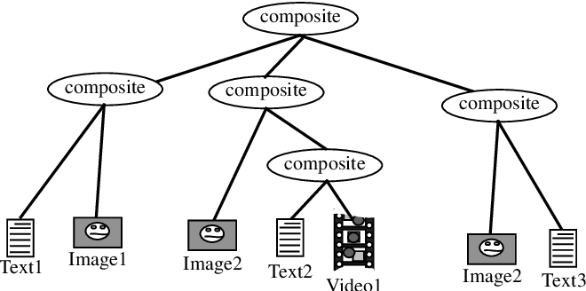

Fig 2.2 Full concept of multimedia authoring

Source: https://www.google.com/search?q=multimedia+authoring&rlz=

Multimedia authoring was an essential tool in the translation of English to any native language via a human audio record system and the record is played alongside to the written or typed text for large or small scale usage. The human factor is essential and cannot be denied in the development of a simple audio- text voice translator system. The form the composition which is further broken into other compositions for readability and translation.

**2.3.3 INEFFICIENCY OF THE EXISTING SYSTEM IN LIKES TO LANGUAGE TRANSLATION**

A few mentioned above such as the MS WORD and the multimedia authoring has a few disadvantages such includes:

1. Poor translation mode
2. Turnaround time is longer
3. Translators rarely work for free
4. Unless you use a translation agency, with access to thousands of translators, you’re limited to the languages any one translator can work with.
5. Wrong phrases translation and grammatical errors.
   1. **KEY ROLE OF A LANGUAGE TRANSLATOR**

The truth is, the debate over machine versus human translation is an unnecessary distraction. What we should really expand on or be talking about is when to use these two different types of translation services, because they both serve a very valid purpose.

**Machine Translation**

1. When you have a large bulk of content to translate and the general meaning is enough.
2. When your translation never reaches the final audience, e.g. you’re translating a resource as research for another piece of content.
3. Translating documents for internal use within a company provided 100% accuracy isn’t needed as expected.
4. To partially translate large chunks of content for a human translator to improve upon.

**Human Translation**

1. When accuracy is important.
2. Most cases where your translated content is received by a consumer audience.
3. When you have a duty of care to provide accurate translations (e.g. legal documents, product instructions, medical guidelines or health and safety content).
4. When translating marketing material or other texts for creative language uses.

**CHAPTER THREE**

**RESEARCH METHODOLOGY**

**3.0 INTRODUCTION**

This research project is focus on automated language translator for Yoruba Language which works with an integrated Application Programming Language. It has no database table as it generates its data’s from API. Its population of study is focused on translating English language to an indigenous Yoruba language. The method of data collection was through secondary method which involves the integration of Google Language Translator API system. This was used in developing the framework for this project. The proposed methodology is focused on translating English language written in text, phrases, and sentences to Yoruba language. The Design methodology comes with both frontend and an API system which gives English like conversion. Use Case diagram was used for better explanation.

* 1. **METHODOLOGY OF EXISTING SYSTEM**

This project is prepared with of forms; these forms consist of placeholders and text boxes as well as command buttons. The labels were used to put on sight information about the corresponding text boxes and the command buttons was used to set in motion the running of some specified Any system not carefully and thoroughly analysed and designed, in a process of time such system or systems are liable to crash which end up may bring about a huge problem in an organisation.

**PROBLEMS OF EXISTING SYSTEM**

In the course of investigation of the existing system, the following problems were discovered.

1. **ERROR/POOR TRANSMISSION**: This is seen where there is a search for a desire or required translation and hence there is an error in translation
2. **INEFFICIENCY**: Being manual some inefficiencies and inadequacies are observed. Some activities in the recording are repetitive and they are involved in large volume of data. Hence, the resulting irregularities are inevitable.
3. **SMETIMES INACCURACY**: Since a manual system is in existence, it will involve human being. As a result, it is prone to errors from mistakes and omissions by people due to boredom and monotony.
4. **IT EQUIRES A WHOLE LOT OF TIME:** One of the disadvantages in local translation is that getting the resource person may require a whole lots of time.
   1. **AREA AND POPULATION OF THE STUDY**

The area and population of the study is focused on English language words/sentences, phrase, etc to Yoruba Language. Examples of words that were translated:

**TABLE 1.1:** Showing Words, Sentences Recognized and Translated To Speech

|  |  |
| --- | --- |
| **WORDS** | **YORUBA VERSION** |
| Come | wa |
| Here | nibi |
| Hello | hello |
| Word | oro |
| **SENTENCES** | **ENGLISH VERSION** |
| Where are you | Nibo lo wa |
| Today is good | Loni jẹ dara |
| having you around me | nini ọ ni ayika mi |

* 1. **DATA SAMPLING AND FACT FINDING TECHNIQUE**

The method used in sampling data and generating facts was through the use for the language translator converter API for English language to other languages which has an actual translation for Yoruba language

**3.4 PROPOSED METHODOLOGY**

The proposed methodology is Language Translator System for recognizing englishike text, phase and sentences then converting it to its Yoruba equivalent language.

**BENEFITS OF THE NEW SYSTEM**

Computer has been widely proved to be very accurate and able to perform complex computation with less or no errors at all. With the aid of computer and windows based security system there will be more reliability and with less or no complaints will be received from the users. The following solutions will be looked into in the proposed system:

Language translator system from English Language to Yoruba conversion software should have following general features.

* 1. It offers high linguistic accuracy to read out correctly.
  2. It is able to read out long texts with fluent and natural speakers.
  3. It supports multiple languages.
  4. It offers highly tunable & customizable structure.

**3.5 DESIGN METHODOLOGY**

System design is the process of defining the architecture, components, modules, interface, and data for a system to satisfy specified requirement. This could also be seeing as the application of systems theory, to product development. Before the development of software it is very necessary to consider certain design tools. Every software development cycle consist of a phase which is the analysis and the design phase. This is the time of development where the process of defining architectures, components, modules, interfaces and data for system to indicate a specified requirement. This stage is also a stage that can only be done after all necessary feasibility studies has been done in view of the proposed system.

The Language Translator System works by recognising the English text through the API and then converting it to its equivalent Yoruba version.

ENGLISH TEXT, PHRASE, SENTENCE API YORUBA VERSION

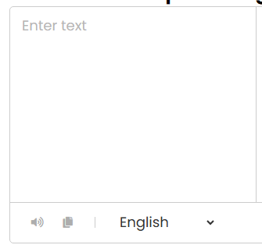

**Fig 3.1:** A Sample Design of an Automated Language System From English Language to Yoruba Language

Making use of HTML, CSS and JAVASCRIPT and INTEGRATED API was used for building the frontend and API system.

**3.5.1 INPUT DESIGN**

This involves the input value and the generated the Yoruba version converted

**TEXT BOX:** This consist of the text, sentence, phrase input for translation.

**Fig 3.2:** A typical Language translation system.

**3.5.2 OUTPUT DESIGN**

Outcome of processed information earlier inputted into system. This program has the following reports as print outs during run time as wished by the users.

**LIST OF DATA ENTERED**

|  |  |
| --- | --- |
| **ENGLISH TEXT** | **YORUBA VERSION** |
| X | X |
| X | X |
| X | X |

**LIST OF OTHER ENTERING**

|  |  |  |
| --- | --- | --- |
| **Main Page** | **Translated Page** | **Text** |
| X | X | X |
| X | X | X |
| X | X | X |

**3.5.3 USE CASE DIAGRAM**

API

ENGLISH TEXT, SENTENCE, PHRASE

YORUBA VERSION

USER

**Fig 3.3** showing a typical way of how a language translator works

**3.6 DATABASE DESIGN**

NO Database and Table was used but the used of Application Programming Interface (API). The API gives the actual English like text to speech conversion.

**CHAPTER FOUR**

**SYSTEM TESTING AND IMPLEMENTATION**

**4.0 INTRODUCTION**

This stage involves the system testing, analysis and implementation. In this stage, the choice of programming and system platform has been determined, system requirements as well, Hardware requirements, software requirements, discussion of findings, report on system testing, etc.

* 1. **CHOICE OF PROGRAMMING AND SYSTEM PLATFORM**

This project was designed using Javascript language for the text to speech recognition which works as the major functionality for the conversion. HTML and CSS for the front end. HTML was used for building the working UI and CSS for the styling of the UI. The system platform used was window OS.

**4.2** **SYSTEM REQUIREMENTS**

The following are the system requirements:

**4.2.1 HARDWARE REQUIREMENTS.**

1. Microsoft Windows XP Professional SP3/Vista SP1/Windows 7 Professional
2. Processor: 2.6 GHz Intel dual core or equivalent
3. Memory: 2 GB Disk space: 1 GB of free disk space
4. Monitor: SVGA Color 15”

**4.2.2 SOFTWARE REQUIREMENTS**

Software plays an important role in any project development. One should understand which software to use to develop the project. Windows 7 is used as an operating system. The application is developed using:

1. Web browser e.g. Mozilla Firefox, internet explorer, Google chrome
2. An update antivirus e.g. Avast, Smadav, etc.
3. Operating system: Windows XP and above

**4.3 DISCUSSION OF FINDINGS**

The area of discussion and findings is the basically on English language text conversion to indigenous Yoruba Language.

### 4.4 REPORT ON SYSTEM TESTING

After a thorough design has been put in place, it was found that the system is efficient enough only accepting English language. The well built Google API is efficient for other local and national languages.

**4.5 SYSTEM DOCUMENTATION AND MAINTAINACE**

The following are the system documentation in details:

**4.5.1 SYSTEM DESCRIPTION**

**A. HOME PAGE:** The homepage or index page displays the frontend of the website, which comprises of text box to enter text, the language translator API and others.

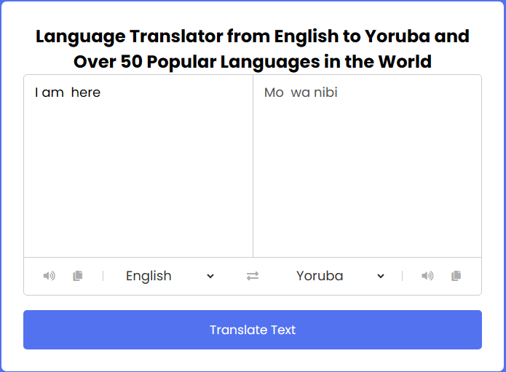

**Fig 4.1:** Index Page of language translator

**B. API:** This is the application interface

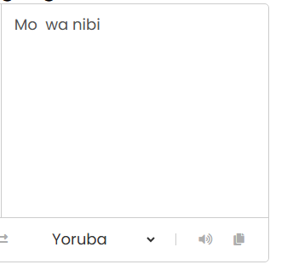

**Fig 4.2:** API of the Index Page of language translator

**4.5.2 MAINTAINANCE**

To maintain the above system, it is required that a good working antivirus is in the Personal Computer of usage and the software source code should not be altered as it may result to mal-functioning of the system.

**4.5.3 HOW TO LOAD AND RUN THE APPLICATION**

**Step 1 -** Install any browser such as Google Chrome, Microsoft Edge, etc

**Step 2** Locate the folder called ‘stt’ in the desktop environment

**Step 3:** Type the address locator in your browser ‘file:///C:/Users/WONDER%20BASSEY%20PAUL/Desktop/stt/

**Step 4: Locate the index page** ‘file:///C:/Users/WONDER%20BASSEY%20PAUL/Desktop/stt/index.html’

**Step 5:** Run the program

**CHAPTER FIVE**

**SUMMARY, CONCLUSION, AND RECOMMENDATION**

**5.0 SUMMARY**

In this project work, an attempt has been made to develop a language translation system. This project can help improve the educational system in the nation, especially finding a good reading and learning assistance aid. We use various methodologies to develop this project, we have faced many problems but we hardly tried to develop this project.

**5.1 CONCLUSION**

Aldo the project is to translate English language and any other Multilingual language to its Yoruba equivalent language. This Translator provides both state-of-the-art English text-to-speech capabilities and complete English transcriptions to handle your multilingual communication needs in a modern and easy way, so you will still know the correct pronunciation of any word.

**5.3 RECOMMENDATION**

After carefully observing the research project, I found out that this automated language translator is best practice if put in use, especially in this era of computer technology where human beings embrace any method that involves the use of a computer system.

**REFERENCES**

Adetugbọ 2013:19-3. (See also the section [Dialects](https://en.wikipedia.org/wiki/Yoruba_language#Dialects).) This widely followed classification is based on Adetugbọ's (2017) dialectological study; the classification originated in his Ph.D. thesis The Yoruba Language in Western Nigeria: Its Major Dialect.

AMuñoz, J. Lasheras, A. Capel, M. Cantabella, and A. Caballero, (2015) “OntoSakai: On the optimization of a Learning Management System using semantics and user profiling,” Expert Syst. Appl., vol. 42, no. 15–16, pp. 5995–6007.

Anil Kumar, PremMithilesh.M, Chandra Kiran. Y, Vinay Gautam S Jaya Kumar, (2020), SOCIAL NETWORKING IN SMARTPHONE through a PROTOTYPE IMPLEMENTATIONS ANDROID”, Journal of Global Research in Computer Science.

Atul. Gonsai and Rushi R. Raval (2020), “Enhance the Interaction Between Mobile Users and Web Services using Cloud Computing”, ORIENTAL JOURNAL OF COMPUTER SCIENCE & TECHNOLOGY.

Bodnar, E. Toddbodnargmailcom, C. Tucker, K. Hopkinson, E. Kennethhopkinsonafitedu, and S. G. Bil, (2014)“Increasing the Veracity of Event Detection on Social Media Networks Through User Trust Modeling,” pp. 636–643.

Borrego M., M. J. Foster, and J. E. Froyd, (2014), “Systematic Literature Reviews in Engineering Education and Other Developing Interdisciplinary Fields,” J. Eng. Educ., vol. 103, no. 1, pp. 45–76.

Cf. For example the following remark by Adetugbọ (2017): "While the orthography agreed upon by the missionaries represented to a very large degree the phonemes of the Abẹokuta dialect, the morpho-syntax reflected the Ọyọ-Ibadan dialects".

Eberhard, David M.; Simons, Gary F.; Fennig, Charles D. (2021)["Ethnologue [yor]"](https://www.ethnologue.com/language/yor). Ethnologue: Languages of the World. SIL International..

[Heine, Bernd](https://en.wikipedia.org/wiki/Bernd_Heine); [Nurse, Derek](https://en.wikipedia.org/w/index.php?title=Derek_Nurse&action=edit&redlink=1) (2010). [African Languages: An Introduction](https://books.google.com/books?id=C7XhcYoFxaQC&pg=PA294). Cambridge University Press. p. 294. [ISBN](https://en.wikipedia.org/wiki/ISBN_(identifier)) [978-0-521-66629-9](https://en.wikipedia.org/wiki/Special:BookSources/978-0-521-66629-9).

["History of Oyotunji"](http://www.oyotunji.org/oyotunji-history.html). Oyotunji. Retrieved 2020-10-13.

Laurie Bauer, (2015), The Linguistics Student's Handbook, Edinburgh  Valdés, Vanessa K-["Yoruba Traditions and African American Religious Nationalism by Tracey E. Hucks (review)"](https://muse.jhu.edu/article/576211). Callaloo. 38 (1): 234–237. [doi](https://en.wikipedia.org/wiki/Doi_(identifier)):[10.1353/cal.2015.0025](https://doi.org/10.1353%2Fcal.2015.0025). [ISSN](https://en.wikipedia.org/wiki/ISSN_(identifier)) [1080-6512](https://www.worldcat.org/issn/1080-6512). [S2CID](https://en.wikipedia.org/wiki/S2CID_(identifier)) [143058809](https://api.semanticscholar.org/CorpusID:143058809).

Nigeria, Know (2017). ["THE OYOTUNJI VILLAGE: A MINI YORUBA EMPIRE IN THE USA"](https://inspireafrika.com/en/the-oyotunji-village-a-mini-yoruba-empire-in-the-usa/). Inspire Afrika. Retrieved 2020-10-13.Ethnologue 22 estimates 45–55 million.

**APPENDIX**

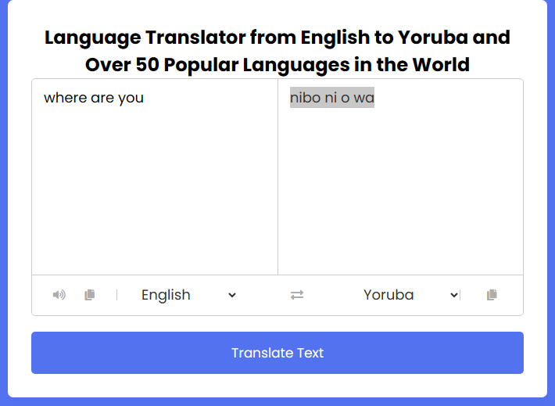

<!-- --------------------- Created By InCoder --------------------- -->

<!DOCTYPE html>

<html>

<head>

<meta charset="UTF-8" name="viewport" content="width=device-width, initial-scale=1"/>

<link rel="stylesheet" type="text/css" href="css/bootstrap.css"/>

<script type="text/javascript" src="http://translate.google.com/translate_a/element.js?cb=googleTranslateElementInit"></script>

</head>

<body>

<nav class=" navbar navbar-default">

<div class="container-fluid">

<a class="navbar-brand" href="https://sourcecodester.com">Amarachi Converter</a>

</div>

</nav>

<div class="col-md-3"></div>

<div class="col-md-6 well">

<h3 class="text-primary">AUTOMATED LANGUAGE TRANSLATOR</h3>

<hr style="border-top:1px dotted #ccc;"/>

<div class="col-md-2"></div>

<div class="col-md-8">

<div class="form-group">

<div class="text">

<textarea placeholder="Enter Text to Convert Here" class="form-control" rows="10" id="text"></textarea>

</div>

<div class="title">Text to Speech Converter</div>

<div class="rate">

<span>1</span>

<p>Speed</p>

<input type="range" min="0" max="3" id="rate" value="1" class="form-control">

</div>

<div class="pitch">

<span>1</span>

<p>Voice Pitch</p>

<input type="range" min="0" max="10" id="pitch" value="1" class="form-control">

</div>

<select id="voices" class="form-control">

</select>

<br><br>

<button class="convert btn btn-info">Convert</button>

</div>

</div>

<br style="clear:both;"/>

<br />

</div>

</div>

</div>

</div>

<script src="script.js"></script></div>

</body>

<script src="js/jquery-3.2.1.min.js"></script>

<script src="js/script.js"></script>

</html>

**JAVASCRIPT**

// --------------------- Created By InCoder ---------------------

let text = document.querySelector('#text')

rate = document.querySelector('#rate')

pitch = document.querySelector('#pitch')

play = document.querySelector('#play')

stopSpeech = document.querySelector('#stop')

convert = document.querySelector('.convert')

voicesOptions = document.querySelector('#voices')

let voices = []

let synth = speechSynthesis

const getVoices = () => {

voices = synth.getVoices()

voices.forEach(voice => {

let option = document.createElement('option')

option.innerText = `${voice.name}`

option.setAttribute('value', voice. name)

option.setAttribute('data-name, voice. name)

option.setAttribute('data-lang', voice. lang)

voicesOptions.appendChild(option)

})

}

getVoices()

if (synth.onvoiceschanged !== undefined) {

synth.onvoiceschanged = getVoices

}

const convertToSpeach = () => {

if (synth. speaking) {

return

}

if (text.value !== '') {

let speakText = new SpeechSynthesisUtterance(text.value)

speakText.onend = e => {

convert.disabled = false

}

speakText.onerror = e => {

console.log('Something Went Wrong....')

}

let selectedVoice = voicesOptions.value

voices.forEach(voice => {

if (voice.name == selectedVoice) {

speakText.voice = voice

}

})

speakText.rate = rate.value

speakText.pitch = pitch.value

convert.disabled = true

synth.speak(speakText)

}

voicesOptions.addEventListener('change', () => {

synth.cancel()

convertToSpeach()

})

rate.addEventListener('change', () => {

synth.cancel()

convertToSpeach()

document.querySelector('.rate span').innerText = rate.value

})

pitch.addEventListener('change', () => {

synth.cancel()

convertToSpeach()

document.querySelector('.pitch span').innerText = pitch.value

})

}

rate.addEventListener('change', () => {

document.querySelector('.rate span').innerText = rate.value

})

pitch.addEventListener('change', () => {

document.querySelector('.pitch span').innerText = pitch.value})